SkySolve Setup Guide.
To be used after skysolve has been loaded onto the SD card- and configured with skysolveSetup.sh script. (Already done if you get the SD card from Dale.)

Note: Power off. Do not just pull the power cord.
Instead move the Field/home switch to the opposite side from where it was when booted for the current session. Then watch the green LED inside the case. Wait for it to do an even spaced 9 blinks. Then you can remove the power. Doing otherwise can corrupt the SD card. The switch must be set in the other position for at least 6 seconds before the shutdown sequence will start.

WIFI
SkySolve on the Raspberry pi comes configured with a default WIFI hot spot. It can also be setup by you to use either your house wifi or the hot spot. There is a switch on top that once it knows your house wifi it can be forced to boot up using it or forced to boot up using the hot spot.

To begin with it can only boot up on it’s own WIFI hot spot and it will create a network SSID called skypixxxx. Where the xxxx is a number. Each skysolve has a different number so that many can be close to one another on the field. Once power is applied it takes 2 to 3 minutes for the network to show up on your wifi list of networks on your computer, tablet or phone that has WiFi.

Once the network shows up switch your computer you are going to use to talk to it to that wifi network. Login to the Pi first with an SSH client or a VNC client. Both are enabled. I will discuss the VNC way to do it first.

VNC to set home network

1. On your computer that has VNC client app on it switch it to the skypixxxx WiFi network using your wifi network setup. The password for the skypixxxx network is 1234567890.

2. Open your VNC client app and connect to 192.168.50.5. User name “pi” password “pi”. Both lower case.

3. If all went well then you can open a terminal window on the RPI GUI desktop screen.

4. Use the terminal window and type:

cd /skysolve/AccessPopup
sudo ./installconfig.sh

5. When the script runs press 5 then the return key. In a few seconds it should list all the wifi networks it finds. Select your house wifi and enter your password. You done. Press 9 to exit.

7. Find your skysolve WiFi on your house network. First on some machine on the network use arp -a to see what ip address are there before the rpi boots. For a windows machine you access the arp -a from the command line. Reboot the RPI with the switch in House position.
This may take a few minutes for it to boot up. Usually 2 or less. Now you have to find out what ip address it was given by your router. Use apr -a again until the new IP address shows up. Then I try to use a browser to connect to that IP:5000 . That should bring up the skysolve web page.

Another way is to compare mac addresses (physical address) of the RPI with the arp -a command before and after you switch to the house wifi. You can also get the RPI mac address by using the ifconfig command on the rpi command line. It will be the address of the wlan0 device.

8. Option to change the SSID and password.
At this point you can also change the network SSID and password skysolve uses at the Field.
It defaults as explained above to skypixxxx. Where xxxx is a unique number. You can change that to what ever you like and change the password as well. When the script asks you to select a function you can use “2” as the selection to change it’s SSID and password.

9. Reboot skysolve.
Flip the field/home switch to the other side. Wait 6 seconds and watch for the green light to blink 9 regular blinks. Then cycle the power.

After reboot
At this point skysolve is up and running and listening for SkySafari to ask it position info. It has the postion of the last solve image I did on it.
How to configure SkySafari to talk to SkySolve.
On skysafari select settings and then telescope settings.
Set the telescope type to StellarCat Cat and mount type push to.
Set it to use WIFI
Do not check Auto-Detect SkyFI
set IP address to your skysolve IP address .
Set the port number to 5005.
close the setup and press the connect on the telsecope icon.

Using SSH to set Home network
Both windows and Mac have an SSH app. This will discuss the window 10 version.
1. Start up a command prompt window.
2. Type ssh pi@192.168.50.5
3. Enter “yes” and the “pi” that should give you a linux prompt on the RPI.
4. Now follow the VNC step 4. from above.

Skysolve operation
Trying out SKYSOLVE indoors.
Watch the youtube video about skysolve. https://www.youtube.com/watch?v=IewMli4AJLw
Now you can play with the skysolve web interface. I would try out the replay history images and solve them using the “solve this one” button. Fun to watch Skysafari track those.

In normal use you do not need to know much about or use skysolve web interface.
It can help if you need to focus the camera (already focused correctly if you don’t play with it).

To focus the camera stop the solving to get faster camera response by pressing the “Align” button.
It takes a couple seconds to stop solving the current image. When it stops solving it will display a frame count in the status field that should count up at about 1 per second as it takes images if the current shutter is set to less than one second

Camera Infinity (Back Focus) adjustment.
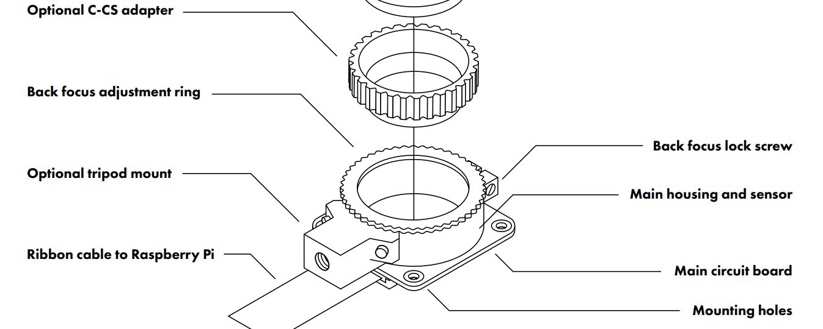
For star focus the lens has been set to infinity at about 1/8 of an inch back turn from infinity stop I think. You can refine it if needed. You may have some far away mountain you can focus on during the day. I don’t so I have to wait for darkness. The infinity stop is adjustable and you can loosen the tiny screw at the top of the lens holder. See RPI Hi Quality camera online manual. The tiny screw driver is supplied by RPI people just for that purpose. Then you can adjust the knurled knob of the lens holder as desired. A fun thing to play with but a bitch to get just right.

